Week 4 Internship Documentation
Infosys Springboard Internship | Data Visualization Domain
Topic Focus: Dataset Understanding, Profiling, KPI Selection, and Dashboard Planning
Prepared by: Hindu Priya Boddu
Project: Optimizing IT Support Team Performance Using Analytics


1. Introduction
During Week 4 of the internship, the focus shifted from learning Power BI and Power Query concepts to working directly with the actual project dataset. This week was highly important because it connected the dataset structure with the business problem statement. The main activities included understanding the dataset in depth, profiling the data, identifying cleaning requirements, selecting relevant KPIs, and planning the dashboard design for the project titled 'Optimizing IT Support Team Performance Using Analytics.'
This week represents the transition from technical learning to business-driven analytics. Instead of only learning tools, the work was now focused on how the dataset can answer real business questions and support better decision-making for an IT support team.

2. Dataset Introduction
The dataset used for this project contains academic performance information of 100 students and is designed to analyze the factors influencing student achievement across multiple subjects. The data represents a structured educational dataset combining demographic attributes, parental background, and academic scores.
The primary objective of using this dataset is to understand how different variables such as gender, ethnicity, parental education level, and test preparation status impact students’ performance in Mathematics, Reading, and Writing examinations.
Each record in the dataset corresponds to an individual student and includes both categorical variables (describing student characteristics) and numerical variables (representing subject scores). This combination enables comprehensive Exploratory Data Analysis (EDA), performance comparison, and insight generation through data visualization.
The dataset serves as a practical example for applying the complete data analytics workflow, including:
- Raw data understanding
- Data cleaning and preprocessing
- Data transformation using Power Query
- Exploratory Data Analysis (EDA)
- KPI creation and dashboard visualization in Power BI
By analyzing this dataset, meaningful insights can be generated to help educators and institutions identify performance patterns, evaluate the effectiveness of preparation programs, and support data-driven academic decision-making.

3. Dataset Column Understanding (Data Dictionary)
The dataset contains performance records of 100 students.
Column Name | Description
Student ID | Unique identifier for each student
Gender | Student gender
Ethnicity | Ethnic group classification (Group A, B, C, D, E)
Parental Education | Associate's Degree, Bachelor's Degree, High School, Master's Degree, Some College, Some High School
Test Preparation | Completion status of preparation course (Completed / Not Completed)
Math Score | Mathematics exam score
Reading Score | Reading exam score
Writing Score | Writing exam score

4. Understanding the Dataset More Deeply
The Student Performance dataset contains academic and demographic information of 100 students, used to analyze factors influencing student achievement. Each record represents an individual student and includes both categorical and numerical data, enabling comprehensive analysis.
The dataset combines background attributes such as gender, ethnicity, parental education level, and test preparation status with academic performance scores in Mathematics, Reading, and Writing. This structure helps in understanding how personal and educational factors impact student outcomes.
Categorical variables are used to compare performance across different groups, while numerical variables allow statistical analysis such as average score calculation, distribution analysis, and performance comparison.
Understanding the dataset helped in identifying data types, validating data quality, and preparing the data for cleaning, transformation, exploratory data analysis (EDA), and visualization in Power BI.

5. Data Profiling
Data Profiling is the process of examining and analyzing the dataset to understand its structure, quality, and overall characteristics before performing data cleaning and analysis. In this project, data profiling was carried out using Power Query and Power BI column quality features to evaluate data completeness, consistency, and accuracy.
During data profiling, key aspects such as data types, missing values, unique categories, column distribution, and value ranges were analyzed. Column quality indicators helped identify valid records, errors, and empty values, while distribution analysis provided insights into score patterns and possible outliers.
This step ensured a clear understanding of the dataset and helped prepare reliable data for further transformation, exploratory data analysis (EDA), and dashboard creation.

6. Cleaning the Actual Support Ticket Dataset
Data cleaning was performed on the Actual Support Ticket dataset to ensure data accuracy, consistency, and reliability before analysis. Since raw ticket data often contains missing values, formatting issues, and inconsistent entries, preprocessing was necessary to prepare the dataset for meaningful analytics.
Using Power Query in Power BI, several cleaning operations were applied, including removing blank rows, correcting data types, trimming extra spaces, and cleaning non-printable characters. Inconsistent categorical values such as ticket status and priority levels were standardized to maintain uniformity across records.
Columns were split where required to extract useful information, and unnecessary or duplicate records were removed to improve data quality. These steps helped create a structured and analysis-ready dataset, enabling accurate KPI calculation, performance analysis, and dashboard visualization.

7. KPI Selection Based on the Actual Dataset
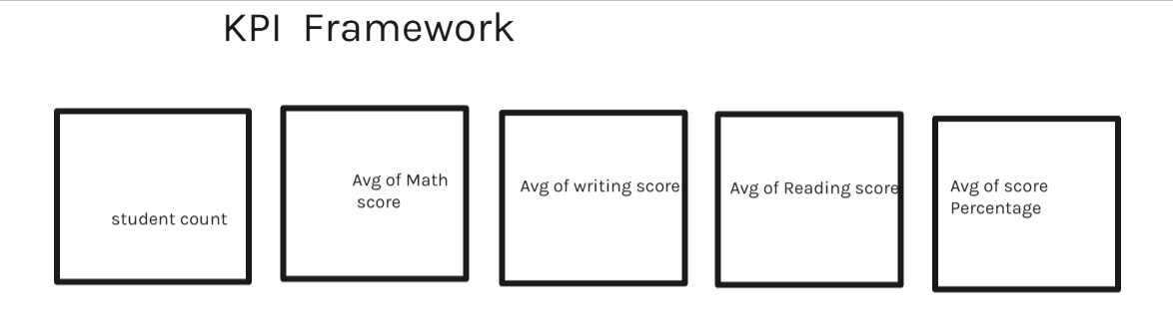
Figure 2: Illustrative KPI framework selected for the Week 4 dashboard

8. Dashboard Planning
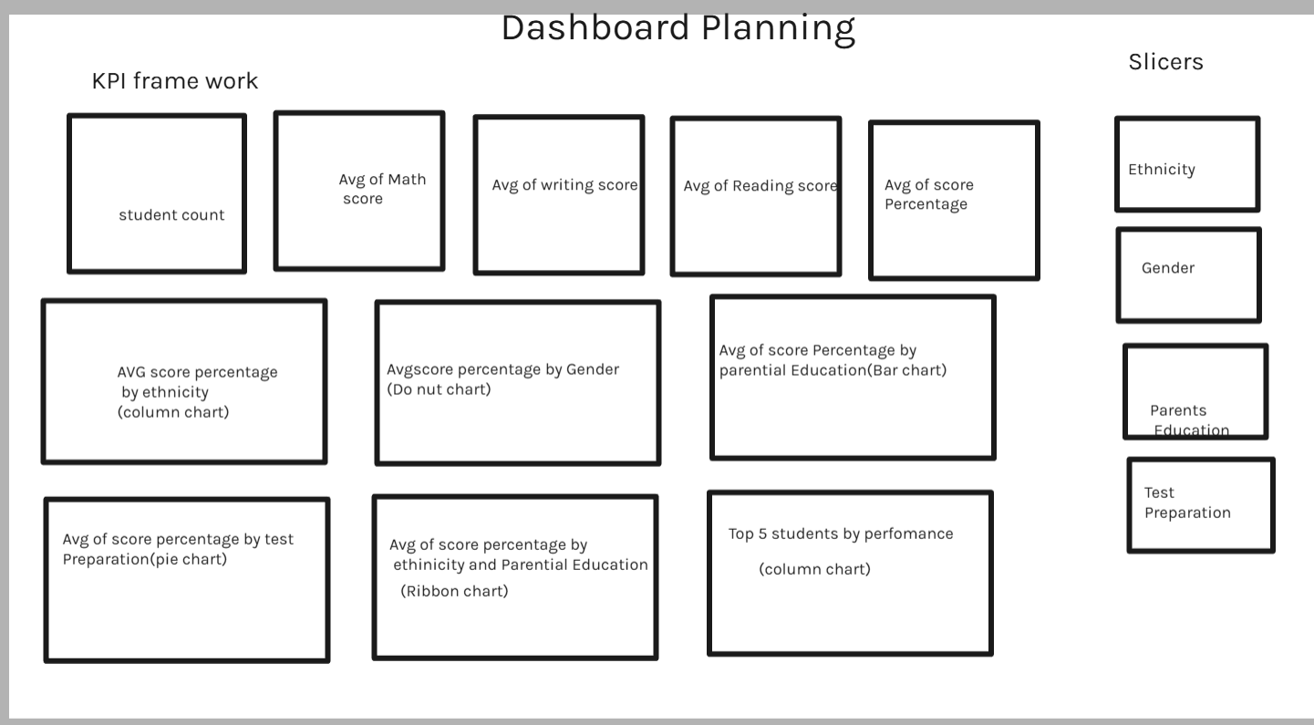
The planning phase of the Student Performance Analysis Dashboard focused on transforming raw student data into meaningful and easy-to-understand insights. Before developing the dashboard in Power BI, a structured approach was followed to identify objectives, required metrics, and suitable visualizations.
The first step in planning was to clearly define the purpose of the dashboard. The main objective was to analyze student academic performance and understand how different factors such as gender, ethnicity, parental education level, and test preparation influence examination scores. The dashboard was designed to help users quickly identify trends, compare performance among groups, and make data-driven observations.
After defining the objective, the dataset was carefully studied to understand available attributes and relationships between variables. Important fields such as Math Score, Reading Score, and Writing Score were selected as performance indicators, while demographic fields like Gender, Ethnicity, and Parental Education were chosen for comparative analysis.
Next, Key Performance Indicators (KPIs) were planned to provide a quick overview of student performance. Metrics such as total student count, average math score, average reading score, average writing score, and overall average percentage were identified as essential summary measures. These KPIs were placed at the top of the dashboard to give users an immediate understanding of overall performance.
During planning, appropriate visualizations were selected based on the type of analysis required:
- Bar charts were chosen for category comparisons.
- Donut and pie charts were used to represent proportional distributions.
- Column charts were used to highlight top-performing students.
- Combined visuals were designed to analyze relationships between multiple variables.
Interactive filters were also included in the planning stage to allow users to explore the data dynamically. Filters for ethnicity, gender, parental education, and test preparation were added so users could customize analysis without modifying the dashboard structure.
Special attention was given to dashboard layout and user experience. The visuals were arranged logically from summary information at the top to detailed analysis at the bottom. This structure ensures that users first understand overall performance and then move toward deeper insights.
Overall, the dashboard planning phase ensured that the final solution was not only visually appealing but also analytical, interactive, and user-friendly, enabling effective interpretation of student performance data.
📈 Visualization Selection
Each visualization in the dashboard was selected based on the type of data and the analytical question being addressed.
- KPI Cards were used to highlight important summary metrics such as average scores and total students.
- Bar Charts were used to compare performance across categories like ethnicity and parental education.
- Donut Chart was chosen to represent gender-based distribution clearly.
- Pie Chart was used to show the proportion of students completing test preparation.
- Column Chart was used to identify top-performing students across subjects.
- Combined visualizations helped analyze relationships between multiple variables simultaneously.
Selecting appropriate visuals improved readability and helped communicate insights effectively.

9. Problem Statement Mapping to Visuals
Problem / Analytical Question | Visualization Used | Purpose of the Visual
What is the overall academic performance of students? | KPI Cards (Average Scores & Student Count) | Provides a quick summary of overall performance and dataset size.
How do students perform across different subjects? | KPI Cards (Math, Reading, Writing Averages) | Helps compare subject-wise performance levels.
Does gender influence student performance? | Donut Chart – Average Score by Gender | Compares academic outcomes between male and female students.
Are there performance differences among ethnic groups? | Bar Chart – Average Score by Ethnicity | Identifies variations in performance across ethnic categories.
How does parental education impact student scores? | Bar Chart – Average Score by Parental Education | Shows relationship between parent education level and student achievement.
Does test preparation improve performance? | Pie Chart – Test Preparation Analysis | Highlights performance differences between prepared and non-prepared students.
Who are the top-performing students? | Column Chart – Top 5 Students by Performance | Identifies high achievers based on subject scores.
How do multiple factors influence performance together? | Combined Chart – Ethnicity & Parental Education | Enables deeper comparative analysis across multiple variables.
How can users explore customized insights? | Interactive Filters (Slicers) | Allows dynamic analysis based on selected categories.

10. Business Questions Answered by the Dashboard
1. Overall Performance Analysis
- What is the overall academic performance of students?
- What are the average scores in Mathematics, Reading, and Writing?
- What is the overall performance percentage of students?
👉 Answered using KPI summary cards.

2. Gender-Based Performance Analysis
- Do male and female students perform differently?
- Is there a significant performance gap between genders?
👉 Answered using the Gender comparison visualization.

3. Ethnicity-Based Performance Analysis
- Which ethnic group shows higher academic performance?
- Are student scores consistent across different ethnic categories?
👉 Answered using the Average Score by Ethnicity chart.

4. Impact of Parental Education
- Does parental education level influence student performance?
- Which parental education category is associated with higher scores?
👉 Answered using the Parental Education comparison chart.

5. Effectiveness of Test Preparation
- Does completing a test preparation course improve student performance?
- How do prepared students compare with non-prepared students?
👉 Answered using the Test Preparation analysis visual.

6. Identification of High Performers
- Who are the top-performing students based on academic scores?
- Which students consistently achieve high results across subjects?
👉 Answered using the Top Performers visualization.

7. Interactive Exploration Questions
- How does performance change when filtering by gender, ethnicity, or parental education?
- Which student groups perform better under specific conditions?
👉 Answered using interactive dashboard filters (slicers).

11. Expected Insights from the Dataset
1. Overall Academic Performance
The dashboard provides a clear understanding of the general performance level of students through average scores and overall percentage indicators. Users can quickly determine whether student performance is below, average, or above expected academic standards.

2. Subject-Wise Performance Trends
The analysis highlights how students perform across Mathematics, Reading, and Writing subjects. This helps identify which subject areas require additional academic support or improvement strategies.

3. Gender-Based Performance Patterns
The dashboard reveals whether there are noticeable differences in performance between male and female students. This insight helps evaluate equality in learning outcomes and academic achievement.

4. Influence of Ethnicity on Performance
By comparing scores across different ethnic groups, the dashboard helps identify performance variations and understand whether academic outcomes differ among student categories.

5. Impact of Parental Education
The dashboard is expected to show how parental education levels relate to student achievement. Higher parental education may indicate increased academic support or learning environment advantages.

6. Effectiveness of Test Preparation Programs
One of the key insights is understanding whether students who completed test preparation courses perform better than those who did not. This helps evaluate the effectiveness of preparation programs.

7. Identification of High-Performing Students
The dashboard highlights top-performing students, enabling recognition of academic excellence and helping institutions understand characteristics associated with high achievement.

8. Comparative and Interactive Insights
Using filters, users can explore customized insights by selecting specific groups. This enables deeper analysis and comparison across multiple factors simultaneously.

Analytical Value
The expected insights from the dashboard support:
- Better understanding of student learning patterns
- Identification of performance gaps
- Evaluation of academic support initiatives
- Data-driven educational decision-making
Overall, the dashboard serves as a practical analytical tool for transforming educational data into actionable knowledge.

12. Why Week 4 Is Important in the Internship
- The actual dataset was understood in depth
- Data profiling identified the quality and structure of the dataset
- Cleaning requirements were planned based on real columns
- Relevant KPIs were selected for the dashboard
- Business questions were identified for decision-making
- The problem statement was mapped directly to Power BI visuals

13. Week 4 Learning Summary
In Week 4, the internship work became more project-specific and business-oriented. The actual support ticket dataset was explored in detail, and each column was studied for its analytical relevance. Data profiling was performed to identify quality issues, data types, and possible inconsistencies. Based on the structure of the dataset, cleaning requirements were defined and KPI selection was completed. A multi-page dashboard structure was also planned so that the final Power BI report can answer key business questions related to response efficiency, resolution efficiency, SLA compliance, escalation behavior, and customer satisfaction.

14. Conclusion
Week 4 was one of the most important stages of the internship because it directly connected the dataset to the business goal of the project. By understanding the actual support ticket dataset in depth, profiling the data, planning the cleaning strategy, selecting meaningful KPIs, and designing the dashboard structure, the project moved from learning mode into solution-building mode. This week provides a strong foundation for the upcoming stages of Power BI dashboard development and business insight generation.

